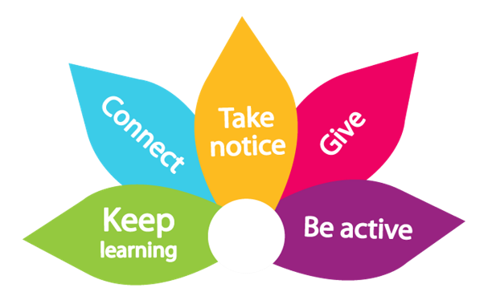

5 ways of wellbeing
Listen to the talk:


Read the transcript
Hello, my name is Emily Kenworthy, and I am an occupational therapist working within NLPSS occupational health. As part of the Society of Occupational Medicine Week we want to promote ways you can help support your health and wellbeing. Today I will be talking about the 5 ways of wellbeing which is an evidence-based way to help promote good health and wellbeing.
The 5 ways of wellbeing are connect, be active, taking notice, learning and give to other.
I will discuss each way of wellbeing and give you ways that you can do each of them. Whilst you are listening you may benefit from reflecting or thinking about what you do now to help your wellbeing and what you may start doing to help your wellbeing.
🤝 1. Connect
The first one is connecting with people. Ongoing evidence shows having connection with colleagues, friends and family help us feel supportive and can help reduce isolation and increase mental health. In the NHS we can get busy and only talk about work tasks but checking on others and having lunch with others can help build up teamwork and help everyone.
You may want to try the following:
- Have a bring and share lunch for a celebration such a birthday or wedding.
- Ask a colleague how they are doing or feeling or check in with someone.
🚶‍♂️ 2. Being active
Being active doesn’t mean you need to run marathons on a regular basis or start a new crazy gym routine. Being active means building movement during the day and working week. Evidence shows that doing exercise can help prevent mental health and physical health issues. And doing it little and often tends to have better benefits.

Ways you can be active are:
- walking part of your daily commute
- in team meetings have a movement break
- if you can, do walking meetings
- do activities you enjoy such as gardening, swimming, walking or running
👀 3. Take notice
Taking notice encourages us to think about our environment and what is going on around us. In busy environments we can go into auto pilot and go through shifts or days without noticing things or stopping. Taking notice encourages us to be mindful in situations and pause and be present.
Try things such as breathing exercises (taking 30 seconds to breathe deeply). When doing exercise think about your environment (what colour are the leaves and the use of your senses). I always find walking and being mindful can be helpful to support my health and wellbeing. Another way is to think about positives that have happened in your day or within the team.
📖 4. Keep learning
Learning can help us grow and stay motivated. I know working in NHS settings we can be learning new clinical skills, but this way of wellbeing doesn’t focus on this entirely. You may want to learn a new skill such as language, hobby, or a sport. Learning helps develop other skills and builds our confidence and resilience when doing those tasks.
You could try learning a new language using an app or thinking about a new hobby or skill you have wanted to do. Remember developing skills at work can be a way to do this way of wellbeing.
🎁 5. Give
In NHS roles we are always giving to support our patients and clients, but we can also give outside of our normal day-to-day duties. Giving is not always about donating charity or volunteering for hours. It can be small acts of kindness and support such as being present for someone.
Doing things such as saying thank you, showing appreciation to a colleague, mentoring, or supervising someone can make a difference.
I hope you have found this helpful and his given you opportunity to reflect on ways that you are doing the 5 ways of wellbeing or given you ideas to help start incorporating the 5 ways of wellbeing to help support your overall health and wellbeing.
If you would like any further support from NLPSS occupational health, please visit your trust intranet for further details.
Thank you for listening.

